Activity 1 | Activity Description | Coaching Considerations
 | Tag: | • | Dribbling with
 |  |  | different surfaces of
 | All players dribbling a soccer ball will try to tag each
 |  |  | the foot
 | other with their hands. Players cannot abandon their
 |  | • | Ability to stop and go
 | own ball to tag.
 |  | • | Dribble with the head
 | Coach: Have players keep count of their own tags. If |  | up
 | playing more than one game, have players improve their | • | Sudden change of
 | tags by 1, 2 or 3 more than before. |  | direction
 |  |  | Time: 6 minutes
Activity 2 | Activity Description | Coaching Considerations
 | Knock Out: | • Protecting the ball
 | All players are dibbling in a 20x25 yard grid and are | • Dribbling with
 | trying to knock other dribblers’ balls outside the grid. |  | different surfaces of
 | Players must retrieve the ball quickly and get back in the |  | the foot
 | game.
 | Coach: Have your players perform a skill task before
 | re-entering the grid. i.e.: juggling 3-5 times, ball taps.
 |  |  | Time: 8 minutes
Activity 3 | Activity Description | Coaching Considerations
 | Steal-Shield: | • Body sideways on to
 | Pair up the players with one ball. One player starts with |  | opponent
 | the ball and at coach’s command, his/her partner tries to | • Use arm to protect and
 | steal the ball away. Play 30-45 second matches. The
 |  |  | know where defender is
 | player that ends with the ball gets a point. If the ball
 |  |  | going
 | goes out of bounds, one of the players must get it back
 |  | • | Knees bent
 | in play very quickly.
 |  | • Turn as defender
 | Coach: Show proper shielding technique during the |  | attacks or reaches for
 | demonstration. Fix technical shielding errors throughout |  | the ball
 | the activity to assure that the group is doing it properly. |  | Time: 8 minutes
Activity 4 | Activity Description | Coaching Considerations
 |  | • Application of
 |  |  | dribbling, | and passing-
 | 3v3 to End Zones: |  | receiving | technique
 |  |  | under pressure
 | In a 20x25 yard grid, place an End Zone of one yard
 |  | • 1v1 defending
 | wide along each end line. Players will score by dribbling
 |  | Decision making
 | and stopping the soccer ball in the End Zone. Defenders
 | can’t defend in the End zone.
 |  |  | Time: 8 minutes
Scrimmage | Activity Description |  | Time
 | 3v3 in your area or 4v4 against the team practicing
3v3 or 4v4 | Next to you |  | 30 minutes
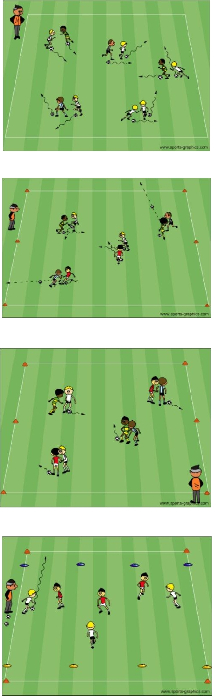

PDF to Word

