Activity 1 | Activity Description | Coaching Considerations
 | Steal-Shield: | • Body sideways on to
 | Pair up the players with one ball. One player starts with | opponent
 | the ball and at coach’s command, his/her partner tries to | • Use arm to protect and
 | steal the ball away. Play 30-45 second matches. The
 |  | know where defender is
 | player that ends with the ball gets a point. If the ball
 |  | going
 | goes out of bounds, one of the players must get it back
 |  | • Knees bent
 | in play very quickly.
 |  | • Turn as defender
 | Coach: Show proper shielding technique during the | attacks or reaches for
 | demonstration. Fix technical shielding errors throughout | the ball
 | the activity to assure that the group is doing it properly. | Time: 8 minutes
Activity 2 | Activity Description | Coaching Considerations
 | Capture the Balls: | • How to get the balls
 | Players should be divided into equal teams to play in a | from the center or other
 | grid with each team’s home in the corners. Soccer balls | home bases
 | are in the middle of the grid, with all players starting | • How to defend their
 | inside their home bases. On the coach’s command, the | home base
 | players each get one ball. They try to dribble or pass it | • Decision making: pass
 | into their home base. Players can steal soccer balls from | or dribble
 | their opponent’s home bases.
 | Coach: Call time and each team counts the balls they
 | have collected. | Time: 8 minutes
Activity 3 | Activity Description | Coaching Considerations
 | 1v1 to Cross Goals: | • Keep soccer ball close
 | In a 12x12yd grid, set up a two yard goal (two red and | to feet
 | blue goals) on each side of the grid. Divide the team into | • Sudden change of
 | two groups. One attacker starts with a soccer ball, trying | direction
 | to score by dribbling through any of the two further | • Burst of speed
 | goals. The defender is trying to defend the goals closest | • Defending – tackling
 | to them, If the defender gets the ball, he/she tries to | • Shielding
 | score in the opponent’s goal. | • Decision making
 | The game ends when one player scores or the ball rolls
 | out. Two new players go. | Time: 8 minutes
Activity 4 | Activity Description | Coaching Considerations
 |  | • Application of
 | 2v2 to Cross Goals: | dribbling, passing-
 | In a 12x12yd grid, set up a two yard goal (two red and | receiving technique
 | blue goals) on each side of the grid. Divide the team into | under pressure
 | two groups. The attackers start with a soccer ball, trying | • 1v1 defending
 | to score by dribbling or passing through any of the two | • Decision making
 | further goals. The defenders are trying to defend the
 | goals closest to them. If a defender gets the ball, he/she
 | tries to score in the opponent’s goal.
 |  | Time: 8 minutes
Scrimmage | Activity Description | Time
 | 3v3 in your area or 4v4 against the team practicing
3v3 or 4v4 | Next to you | 30 minutes
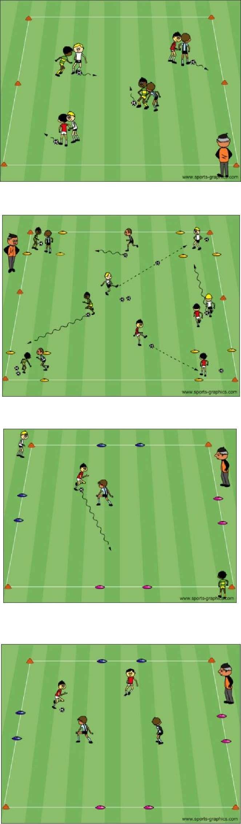

PDF to Word

