Activity 1 |  | Activity Description |  |  |  | Coaching Considerations
 | Paint the Field- Passing: |  |  |  |  | • Passing and receiving
 | In pairs, players will pass the soccer ball back and forth |  |  |  |  | technique
 | in a 20x25 yard grid. Explain to the players that their |  |  |  |  | • Weight of the pass
 | soccer ball is a paint brush and wherever it rolls it will
 |  |  |  |  |  | • Ability to pass through
 | paint the area. Their task is to pass (kick) the soccer ball
 |  |  |  |  |  | traffic
 | to paint as much of the grid as possible in the allotted
 |  |  |  |  |  | • Communication and
 | time.
 |  |  |  |  |  | mobility of the players
 | Version 2: Tell the players to use the other foot |  |  |  |  | Time: 6 minutes
Activity 2 |  | Activity Description |  |  |  | Coaching Considerations
 | British Bulldog: |  |  |  |  | • Changing speed and
 | All players are dribbling a soccer ball from one end to
 |  |  |  |  |  | direction
 | the other end of a 20x25 yard grid. The coach begins as
 |  |  |  |  |  | • Running with the ball
 | the “bulldog” and tries to kick the dribbling players’
 | soccer balls out of the grid. Once a player’s soccer ball |  |  |  |  | • Keep the ball close
 | is kicked out of the grid, he/she becomes a “bulldog”. |  |  |  |  | • 1v1 defending
 | Coach: Have players change direction and accelerate
 | away. Have players demonstrate a move and accelerate
 | away.
 | Version 2: Players who dribble the soccer ball close to |  |  |  |  | Time: 8 minutes
 | their feet do not get attacked by the bulldog.
Activity 3 |  | Activity Description |  |  |  | Coaching Considerations
 | Doctor, Doctor: |  |  |  |  | • Dribbling Technique
 | Divide the group into two teams. Send them to their
 |  |  |  |  |  | • Protect the ball
 | hospital | (corner boxes). Each | team | selects a | doctor.
 |  |  |  |  |  | • Passing technique
 | He/she | will cure (unfreeze) | his/her | team’s | players.
 |  |  |  |  |  | • Weight and accuracy of
 | Teams try to freeze each other by hitting the players
 |  |  |  |  |  | the pass
 | with their soccer balls below knees or striking their
 | balls. When frozen, players must put ball above head,
 | remain in place, and yell “Doctor, Doctor”. The Doctor
 | is without a ball, and is safe in the hospital, but when he
 | comes out, he can be frozen. When the doctor is frozen |  |  |  |  | Time: 8 minutes
 | the game is over.
Activity 4 |  | Activity Description |  |  |  | Coaching Considerations
 |  |  |  |  |  | • Application of
 | 3v3 to Small Goals: |  |  |  |  | dribbling, passing-
 | Divide the 20x25 yard grid into to equal grids of 12x20 |  |  |  |  | receiving and shooting
 | yards. Place a 3yard goal with cones on each end line. |  |  |  |  | technique under
 | Players will score by dribbling or passing through the |  |  |  |  | pressure
 | goal they are attacking. |  |  |  |  | • 1v1 defending
 |  |  |  |  |  | • Decision making
 | Coach: If you have extra players, make sure you sub
 | them in.
 |  |  |  |  |  | Time: 8 minutes
Scrimmage |  | Activity Description |  |  |  | Time
 | 3v3 in your area or 4v4 against the team practicing
3v3 or 4v4 | Next to you |  |  |  |  | 30 minutes
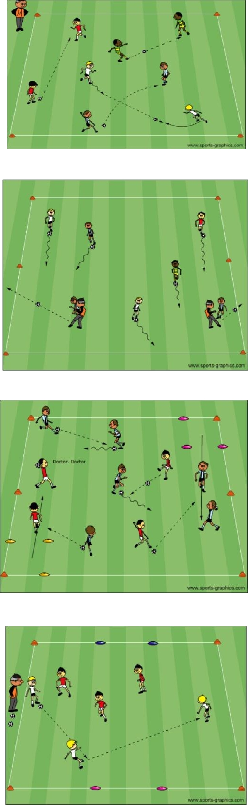

PDF to Word

