|  |  |  |  |  |  |  |  |  |  |  |  |  |  |
| --- | --- | --- | --- | --- | --- | --- | --- | --- | --- | --- | --- | --- | --- |
| **Activity 1** |  |  |  | **Activity Description** | | | |  |  |  |  | **Coaching Considerations** |  |
|  | **Paint the Field- Passing:** | | | | | |  |  |  |  |  | • Passing and receiving |  |
|  |  |  |  |  |  | technique |  |
|  | In pairs, players will pass the soccer ball back and forth | | | | | | | | | | |  |
|  | • Weight of the pass |  |
|  | in a 20x25 yard grid. Explain to the players that their | | | | | | | | | | |  |
|  | • Ability to pass through |  |
|  | soccer ball is a paint brush and wherever it rolls it will | | | | | | | | | | |  |
|  | traffic |  |
|  | paint the area. Their task to pass (kick) the soccer ball to | | | | | | | | | | |  |
|  | • Communication and |  |
|  | paint as much of the grid as possible in the allotted time. | | | | | | | | | | |  |
|  | mobility of the players |  |
|  |  |  |  |  |  |  |  |  |  |  |  |  |
|  | **Version 2:** Tell the players to use the other foot | | | | | | | | |  |  | **Time: *8 minutes*** |  |
|  |  |  |  |  |  |  |  |  |  |  |  |  |
|  |  |  |  |  | | | |  |  |  |  |  |  |
| **Activity 2** |  |  |  | **Activity Description** | | | |  |  |  |  | **Coaching Considerations** |  |
|  | **Team Tag:** | | |  |  |  |  |  |  |  |  | • Dribbling technique |  |
|  | Split | the | players | | into | two | teams | (**Dribblers** | | **and** | | • Passing and receiving |  |
|  |  |  |  |  |  |  |  |  |  |  |  |  |
|  | **Taggers**). The taggers are trying to tag the | | | | | | | | dribblers’ | | | technique |  |
|  |  |  |  |  |  |  |  |  |  |  |  |  |
|  | feet | or soccer | | ball with their soccer ball. The taggers | | | | | | | | • Weight of the pass |  |
|  |  |  |  |  |  |  |  |  |  |  |  |  |
|  | need to keep track of their tags. The dribblers are trying | | | | | | | | | | | • Accuracy of the pass |  |
|  | to keep their | | | ball | from | being | tagged | by shielding | | | it. |  |
|  | • Protecting the ball |  |
|  | After a determine time, the teams switch roles. | | | | | | | |  |  |  |  |
|  |  |  |  |  |  |
|  | **Coach:** Can help taggers adding their points. | | | | | | | |  |  |  |  |  |
|  | **Version** 2: Taggers can only tag the dribblers’ ball. | | | | | | | | |  |  | **Time: *8 minutes*** |  |
|  |  |  |  |  |  |  |  |  |  |  |  |  |
| **Activity 3** |  |  |  | **Activity Description** | | | |  |  |  |  | **Coaching Considerations** |  |
|  | **Clean Your Backyard:** | | | | |  |  |  |  |  |  | • Basic Shooting |  |
|  |  |  |  |  |  |  |  |  |  |  |  |  |
|  | Split the players into two teams to play in a 20x25 yard | | | | | | | | | | | technique |  |
|  |  |  |  |  |  |  |  |  |  |  |  |  |
|  | gird. With | | cones, | | divide | the field into three | | | portions. | | | • Simple decision making |  |
|  | The central portion (**the buffer zone**) is 6yds wide and | | | | | | | | | | |  |
|  |  |  |
|  | no one can enter it. Place three goals (3yds each) at the | | | | | | | | | | |  |  |
|  | far ends of the grid. Players in each team will try to | | | | | | | | | | |  |  |
|  | shoot/pass and score below knee height in any of the | | | | | | | | | | |  |  |
|  | other team’s goals. | | | |  |  |  |  |  |  |  |  |  |
|  | **Coach:** Allow players to enter the buffer zone to retrieve | | | | | | | | | | |  |  |
|  | any ball that has stopped in there. | | | | | |  |  |  |  |  |  |  |
|  | **Version 2:** Allow teams to defend the goals using their | | | | | | | | | | | **Time: *8 minutes*** |  |
|  | hands. | |  |  |  |  |  |  |  |  |  |  |
|  |  |  |  |  |  |  |  |  |  |  |  |
| **Activity 4** |  |  |  | **Activity Description** | | | |  |  |  |  | **Coaching Considerations** |  |
|  | **4 Corner Shooting Without Goalkeepers:** | | | | | | | |  |  |  | • Application of |  |
|  | In 20x25 yard grid with cone goals at each end, players | | | | | | | | | | |  |
|  | dribbling, passing- |  |
|  | of the same team are placed by the corner cones of the | | | | | | | | | | |  |
|  | receiving and shooting |  |
|  | goal they are defending. Half of the team is in a line at | | | | | | | | | | |  |
|  | technique under |  |
|  | one cone and the other half at the other cone. The coach | | | | | | | | | | |  |
|  | pressure |  |
|  | is standing outside the middle | | | | | | with all the balls. The | | | | |  |
|  | • 1v1 defending |  |
|  | game starts when the coach serves the ball into the field. | | | | | | | | | | |  |
|  | • Decision making |  |
|  | The game is over when one team scores or the ball goes | | | | | | | | | | |  |
|  |  |  |
|  | out of bounds. Players need to get out of the field | | | | | | | | | | |  |  |
|  | quickly and get back in line. | | | | | |  |  |  |  |  | **Time: *8 minutes*** |  |
|  | **Version 2:** Add Goalkeepers | | | | | |  |  |  |  |  |  |
|  |  |  |  |  |  |  |  |
| **Scrimmage** |  |  |  | **Activity Description** | | | |  |  |  |  | **Time** |  |
| **3v3 or 4v4** | 3v3 in your area or 4v4 against the team practicing | | | | | | | | | | | **30 minutes** |  |
| Next to you | | | | | | | | | |  |  |
|  |  |  |  |
|  |  |  |  |  |  |  |  |  |  |  |  |  |  |

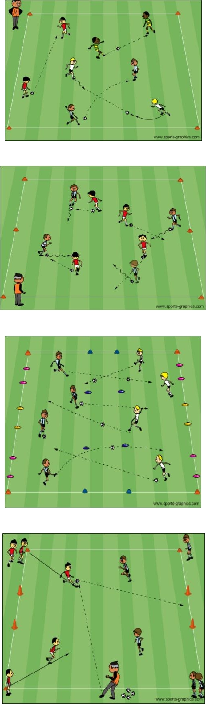

[PDF to Word](http://pdfonline.blogspot.com)