Activity 1 |  | Activity Description |  | Coaching Considerations
 | Shadow Dribble: |  |  | • Keep ball close
 | Two players (Leader and Shadow) both with a ball
 |  |  |  | • Changing directions
 | each and will dribble their soccer ball in a 20x25 yard
 |  |  |  | • Dribbling using
 | grid. The leader will determine where they are going
 |  |  |  | different surfaces of the
 | while the shadow will try to keep up with the leader.
 |  |  |  | foot
 | Coach: Call the change from leader to shadow
 | Version 2: Use only favorite foot or other foot. |  |  | Time: 8 minutes
 | Version 3: Leader must make a move.
Activity 2 |  | Activity Description |  | Coaching Considerations
 | Gate Dribbling: |  |  | • Keep ball close
 | In a 20x25 yard grid set up as many gates (two cones |  |  | • Changing direction
 | about 2 yards apart). All players with a ball must |  |  | • Acceleration after going
 | dribble through the gate in order to score a point. |  |  | through a gate
 | Coach: Have players keep count of how many points |  |  | • Decision making
 | they scored in 30 seconds or a minute. Repeat asking the
 | players to beat the score by one or more points. You can
 | also ask them to dribble with the left or right foot only. |  |  | Time: 8 minutes
Activity 3 |  | Activity Description |  | Coaching Considerations
 | Dribbling Gates With Bandits: |  |  | • Keep ball close
 | In a 20x25 yard grid, set up many gates (two cones
 |  |  |  | • Changing direction
 | about | 2 yards apart). | Select 2-3 players to be the
 |  |  |  | • Acceleration after going
 | “Bandits”; they will try to dispossess the players with
 |  |  |  | through a gate
 | trying to score points by dribbling through the gates.
 | When the bandit steals the soccer ball, the player that |  |  | • Decision making
 | lost the ball becomes the bandit. |  |  | • 1v1 defending
 | Coach: Play multiple 1-2 minute games. Award a point
 | to all players who have a soccer ball at the end of each |  |  | Time: 8 minutes
 | game.
Activity 4 |  | Activity Description |  | Coaching Considerations
 |  |  |  | • Application of
 |  |  |  | dribbling, and passing-
 | 2v2 to End Zones: |  |  | receiving technique
 | Divide | the 20x25 yard | grid into two equal grids of | under pressure
 | 12x20 yards, with a one yard buffer zone in between. |  |  | • 1v1 defending
 | Make a one yard wide End Zone along each end line. |  |  | Decision making
 | Players will score by dribbling and stopping the soccer
 | ball in the End Zone. Defenders can’t defend in the End
 | Zone.
 |  |  |  | Time: 8 minutes
Scrimmage |  | Activity Description |  | Time
 | 3v3 in your area or 4v4 against the team practicing
3v3 or 4v4 | Next to you |  |  | 30 minutes
 | .
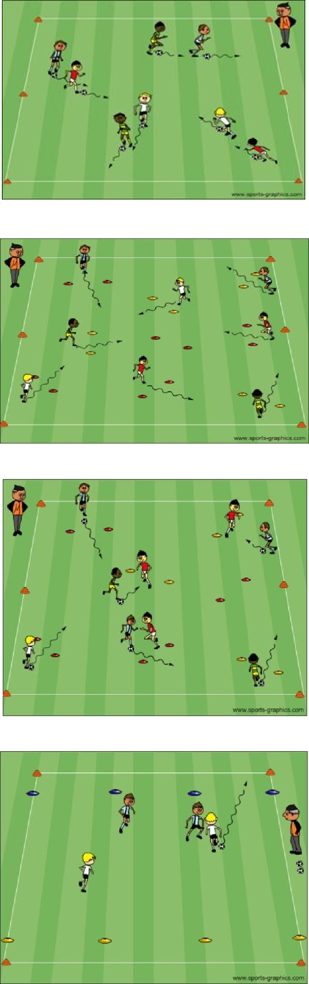

PDF to Word

