Activity 1 |  | Activity Description | Coaching Considerations
 | Shadow Dribble: |  | • Dribbling with head up
 | Two players (Leader and Shadow) each with a ball
 |  |  | • Running with the ball
 | will dribble their soccer balls in a 20x25 yard grid. The
 |  |  | • Using different foot
 | leader will determine where they are going while the
 |  |  | surfaces
 | shadow will try to keep up with the leader.
 |  |  | • Changing direction
 | Coach: Call the change from leader to shadow.
 | Version 2: Use only favorite foot or other foot. |  | Time: 6 minutes
 | Version 3: Leader must make a move.
Activity 2 |  | Activity Description | Coaching Considerations
 | Sharks and Minnows: |  | • Changing speed and
 |  |  | direction
 | In a 20x25 | yard grid, have 3-4 players acting as the
 | sharks. The minnows are in one end of the grid with |  | • Running with the ball
 | their soccer balls. When the coach says “GO”, the |  | • Keep the ball close
 | minnows try to dribble to the other end of the grid and |  | • 1v1 defending
 | the sharks are trying to kick the ball out. When the
 | dribbler’s ball goes out, he/she becomes a shark. If the
 | minnows reach the other end, they will wait for the
 | coach’s command to play again. The game continues
 | until all players turn into sharks. |  | Time: 8 minutes
Activity 3 |  | Activity Description | Coaching Considerations
 | Capture the Balls: |  | • How to get the balls
 | Players should be divided into equal teams to play in a |  | from the center or other
 | grid with each team’s home in the corners. Soccer balls |  | home bases
 | are in the middle of the grid with all players starting |  | • How to defend their
 | inside their home bases. On the coach’s command, the |  | home base
 | players each get one ball. They try to dribble or pass it |  | • Decision making: pass
 | into their home base. Players can steal soccer balls from
 |  |  | or dribble
 | their opponent’s home bases.
 | Coach: Call time and each team counts the balls they
 | have collected. |  | Time: 8 minutes
Activity 4 |  | Activity Description | Coaching Considerations
 |  |  | • Application of
 |  |  | dribbling, passing-
 | 3v3 to 4 Goals: |  | receiving and shooting
 | In a 20x25 yard grid, place a two yard goal with cones |  | technique under
 | close to the corners of each end line. Players will score |  | pressure
 | by dribbling or passing through any of the two goals |  | • 1v1 defending
 | they are attacking. |  | • Decision making
 |  |  | Time: 8 minutes
Scrimmage |  | Activity Description | Time
 | 3v3 in your area or 4v4 against the team practicing
3v3 or 4v4 | Next to you |  | 30 minutes
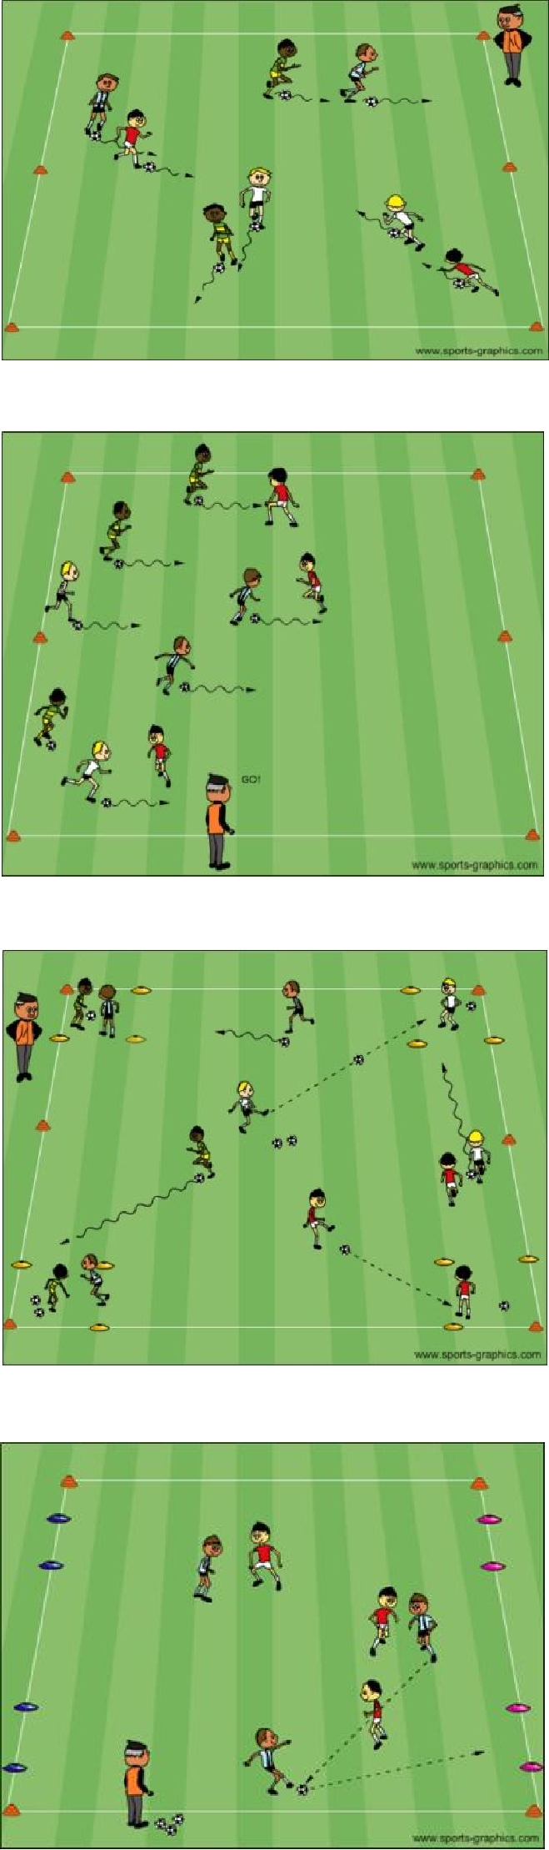

PDF to Word

