Activity 1 |  | Activity Description | Coaching Considerations
 | Gate Passing: |  | • Passing and receiving
 | In a 20x25 yard grid, set up many gates (two cones
 |  |  | technique
 | about 2 yards apart). Players are now in pairs with a
 |  |  | • Dribbling Technique
 | soccer ball. They must pass the soccer ball through the
 |  |  | • Decision Making
 | gate to their teammate in order to score a point.
 |  |  | • Weight and accuracy of
 | Coach: Players count how many points they score in a
 |  |  | the pass
 | minute. Repeat asking the players to beat their score by
 |  |  | • Communication and
 | one or more points. You can also ask them to pass with
 |  |  | mobility
 | the inside or outside of the foot, and using their favorite
 |  |  | Time: 6 minutes
 | foot or with the other foot.
Activity 2 |  | Activity Description | Coaching Considerations
 | Catching Robbers: |  | • Passing technique
 | All players are spread around a 20x25 grid. Only two |  | • Weight of the pass
 | players (the cops) have soccer balls. When the coach |  | • Accuracy of the pass
 | says “let’s catch some robbers”, the cops attempt to
 | catch the robbers who are running around the grid by
 | striking their legs below knee height with their soccer
 | balls. Once a robber is caught, he/she goes and gets any
 | ball from the perimeter and becomes a cop.
 | Coach: Place the balls that are not being used around
 | the perimeter of the grid. |  | Time: 8 minutes
Activity 3 |  | Activity Description | Coaching Considerations
 | Capture the Balls: |  | • How to get the balls
 | Players should be divided into equal teams to play in a
 |  |  | from the center or other
 | grid with each team’s home in the corners. Soccer balls
 |  |  | home bases
 | are in the middle of the grid with all players starting
 |  |  | • How to defend their
 | inside their home bases. On the coach’s command, the
 |  |  | home base
 | players each get one ball. They try to dribble or pass it
 |  |  | • Decision making: pass
 | into their home base. Players can steal soccer balls from
 |  |  | or dribble
 | their opponent’s home bases.
 | Coach: Call time and each team counts the balls they |  | Time: 8 minutes
 | have collected.
Activity 4 |  | Activity Description | Coaching Considerations
 |  |  | • Application of
 | 2v2 to 4 Goals: |  | dribbling, passing-
 | Divide the | 20x25 yard grid into two equal grids of | receiving and shooting
 | 12x20 yards with a one yard buffer zone in between. |  | technique under
 | Place a two 2 yard goal with cones close to the each |  | pressure
 | corners of each end line. Players will score by dribbling |  | • 1v1 defending
 | or passing through any of the two goals they are |  | • Decision making
 | attacking.
 | Coach: have two games going at the same time. If you
 | have extra players, make sure you sub them in.
 |  |  | Time: 8 minutes
Scrimmage |  | Activity Description | Time
 | 3v3 in your area or 4v4 against the team practicing
3v3 or 4v4 | Next to you |  | 30 minutes
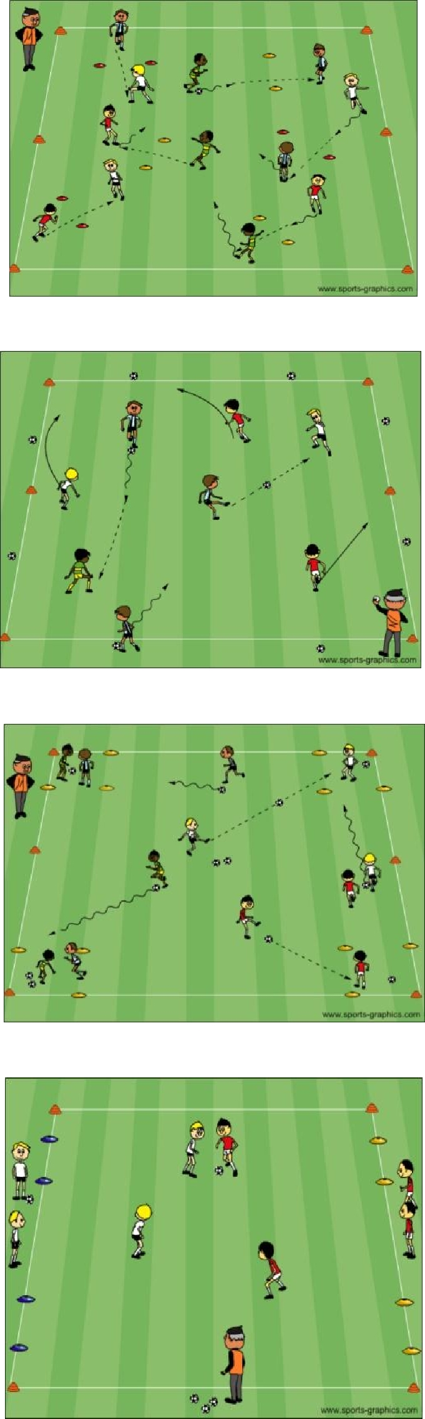

PDF to Word

