Activity 1 |  | Activity Description |  |  |  | Time
 | Gate Dribbling:
 | In a 15x20 yard grid set up as many gates (two cones about
 | 2 yards apart). All players with a ball must dribble through
 | the gate in order to score a point. |  |  |  |  | 6
 | Coach: Have players keep count of how many points they |  |  |  |  | minutes
 | score in 30 seconds or a minute. Repeat asking the players
 | to beat the score by one or more points. You can also ask
 | them to dribble with the left or right foot only.
Activity 2 |  | Activity Description |  |  |  | Time
 | Red Light/Green Light:
 | All players are dribbling freely in a 15x20 yard grid. When
 | the coach says “red light” the players must stop and put
 | their foot on the ball. When the coach says “yellow light”
 | the players must dribble slowly, and when the coach says |  |  |  |  | 6
 | “green light” the players must dribble fast
 |  |  |  |  |  | minutes
 | Coach: Control the frequency of light changes. You can
 | also add other light colors (i.e.: “purple light” = hop back
 | and forth over the ball, “orange light” = run around the
 | ball, “black light” = dance, and “blue light” = hide behind
 | the ball.
Activity 3 |  | Activity Description |  |  |  | Time
 | Shrek/Spiderman/Sponge Bob:
 | All players with a ball (dribblers) with the exception of two
 | players who wear pennies (Shreks) in a 15x20 yard grid.
 | The players with | pennies | are trying | to tag the | dribblers. | 6
 | Once tagged, the | players | must go to | the castle/spidernet.
 |  |  |  |  |  | minutes
 | Dribblers can only get back if another dribbler tags them or
 | the coach uses his/her magic powers.
 | Coach: Make sure all players have a chance to be a Shrek.
Activity 4 |  | Activity Description |  |  |  | Time
 | Catching Robbers:
 | All players are spread around a 15x20 grid; only two players
 | (the cops) have soccer balls. When the coach says “let’s
 | catch some robbers” the cops attempt to catch the robbers
 | who are running around the grid by striking their legs below |  |  |  |  | 6
 | knee height with their soccer balls. Once a robber is caught
 |  |  |  |  |  | minutes
 | he/she goes and gets any ball from the perimeter and
 | becomes a cop.
 | Coach: Place the balls that are not being used around the
 | perimeter of the grid.
Scrimmage |  | Activity Description |  |  |  | Time
3v3 or 4v4 | 3v3 in your area or 4v4 against the team practicing |  |  |  |  | 25 minutes
 | Next to you.
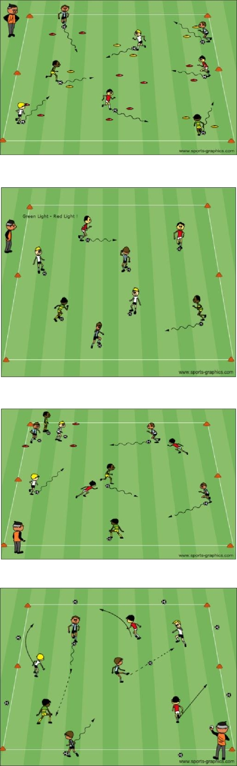

PDF to Word

