Activity 1 | Activity Description |  | Time
 | Juggling:
 | All players with a soccer ball in their hands drop the ball
 | down and try to kick it back up to their hands. Players will
 | try to use their thighs and feet to keep the ball in the air. |  | 6
 | Coach: Have the players count how many times they touch |  | minutes
 | the ball before it hits the ground.
 | Version 2: Controlled juggling - Thigh, foot, catch. Thigh,
 | thigh, foot, catch. Thigh, thigh, foot, foot, catch.
Activity 2 | Activity Description |  | Time
 | Body Part Dribble:
 | All players dribbling a soccer ball. The coach calls out a
 | body part (elbow! - knee!) and the players then touch their
 | ball with that part of the body. |  | 6
 | Coach: Should vary the body parts, number of body parts he |  | minutes
 | calls out, and rate at which he calls them out.
of Activity 3 | Activity Description |  | Time
 | Ball Tag:
 | All players are dribbling a soccer ball in a 15x20 yard grid.
 | The players try to hit another player’s feet or soccer ball
 | with their soccer ball. | Players should keep count of how | 6
 | many times they tag another player.
 |  |  | minutes
 | Version 2: If the players tag the coach, they are awarded 10
 | or 20 points. If the players tag other selected players, they
 | are awarded 50 or 100 points.
Activity 4 | Activity Description |  | Time
 | Cops and Robbers:
 | The coach sets up 8-10 stand up (tall) cones in a 15x20 yard
 | grid. Robbers will strike the ball and try to knock the cones
 | (the banks) down. The cops (2 or 3 players) are without
 | soccer balls and are trying to stand all the cones back up |  | 6
 | before all the banks are robbed. Rotate the cops and the
 |  |  | minutes
 | robbers.
 | Variation 2: If you do not have tall cones, divide the group
 | in half cops and half robbers, and place the cops’ balls on
 | top of discs.
Scrimmage | Activity Description |  | Time
3v3 or 4v4 | 3v3 in your area or 4v4 against the team practicing |  | 25 minutes
 | Next to you
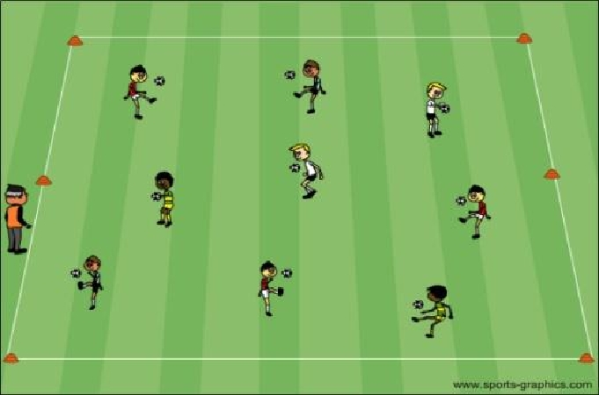
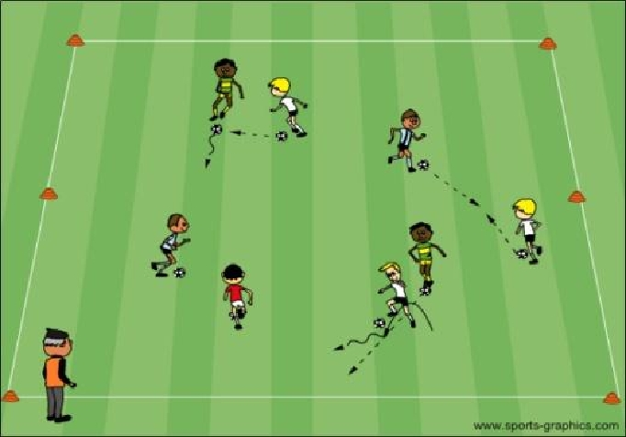
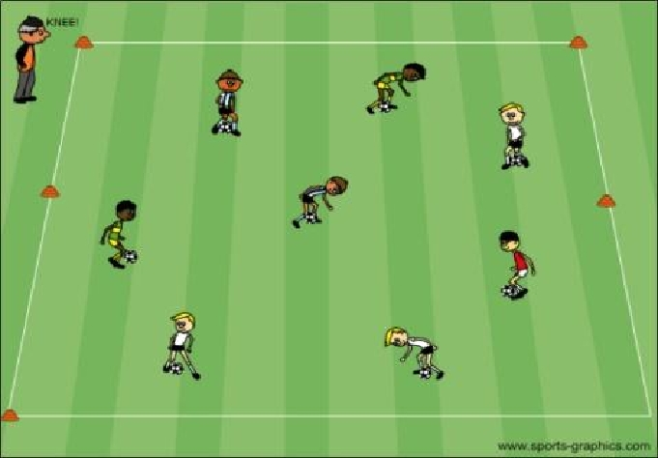
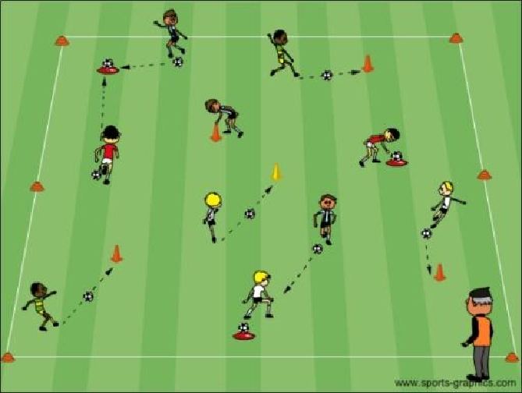

PDF to Word

