Activity 1 |  | Activity Description | Time
 | Paint the Field:
 | All players will dribble their soccer ball in a 15x20 yard grid
 | pretending that is | a paintbrush and wherever it rolls it is | 6
 | painting the field. The players will try to paint as much of
 |  |  | minutes
 | the area as possible in the time allotted.
 | Variation 2: Ask the players to dribble their favorite foot
 | and then dribble with your other foot.
Activity 2 |  | Activity Description | Time
 | Red Light/Green Light:
 | All players are dribbling freely in a 15x20 yard grid. When
 | the coach says “red light” the players must stop and put
 | their foot on the ball. When the coach says “yellow light”
 | the players must dribble slowly, and when the coach says
 | “green light” the players must dribble fast |  | 6
 | Coach: Control the frequency of light changes. |  | minutes
 | Variation 2: Add other light colors and actions (i.e.:
 | “purple light” = hop back and forth over the ball, “orange
 | light” = run around the ball, “black light” = dance, and
 | “blue light” = hide behind the ball.
Activity 3 |  | Activity Description | Time
 | Sharks and Minnows:
 | In a 15x20 yard grid have 3-4 players acting as the sharks.
 | The minnows are in one end of the grid with their soccer
 | balls. When the coach say “GO” the minnows try to dribble |  | 6
 | to the other end of the grid and the sharks are trying to kick
 |  |  | minutes
 | the ball out. When the dribbler’s ball goes out, he/she
 | becomes a shark. If the minnows reach the other end, they
 | will wait for the coach’s command to play again. The game
 | continues until all players turn into sharks.
Activity 4 |  | Activity Description | Time
 | Capture the Balls:
 | Players should be divided into equal teams to play in a grid
 | with each team’s home in the corners. Soccer balls are in the
 | middle of the grid with all players starting inside their home
 | bases. On the coach’s command, the players each get one |  | 6
 | ball. They try to | dribble or pass it into their home base.
 |  |  | minutes
 | Players can steal soccer balls from their opponent’s home
 | bases.
 | Coach: Call time and each team counts the balls they have
 | collected.
Scrimmage |  | Activity Description | Time
3v3 or 4v4 | 3v3 in your area or 4v4 against the team practicing |  | 25 minutes
 | Next to you
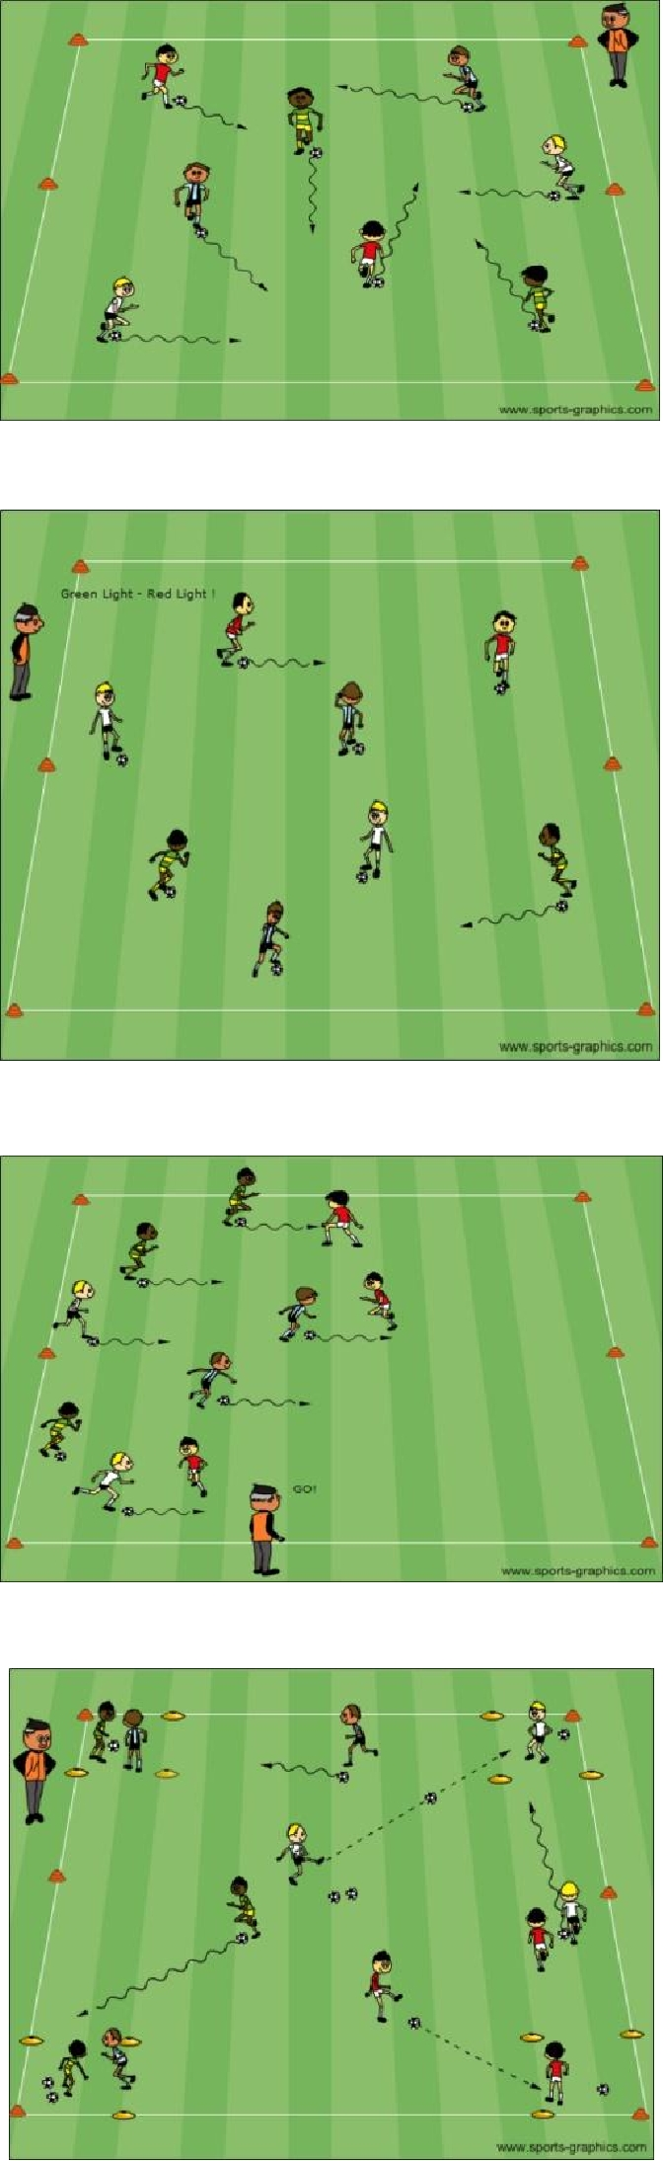

PDF to Word

