Activity 1 | Activity Description |  | Time
 | Paint the Field:
 | All players will dribble their soccer ball in a 15x20 yard grid
 | pretending that it is a paintbrush and wherever it rolls it is |  | 6
 | painting the field. The players will try to paint as much of
 |  |  | minutes
 | the area as possible in the time allotted.
 | Variation 2: Ask the players to dribble their favorite foot
 | and then dribble with your other foot.
Activity 2 | Activity Description |  | Time
 | Kangaroo Jack:
 | In a 15x20 yard grid, two or three players are the kangaroos |  | 6
 | and the other players are dribbling. The kangaroos are trying
 |  |  | minutes
 | to tag the dribblers. Once a dribbler is tagged, he/she turns
 | into a kangaroo.
Activity 3 | Activity Description |  | Time
 | Crab Soccer:
 | Have 3-4 players without soccer balls inside a 15x 20 yard
 | grid acting as crabs. These crabs are standing upright. The
 | other players start anywhere in the grid and when the coach |  | 6
 | says “GO” they dribble their soccer balls around, avoiding |  | minutes
 | the crabs. The crabs try to kick the balls out of the grid. If a
 | dribbler’s ball goes out of the grid, that player becomes a
 | crab as well. Play until all players turn into crabs.
Activity 4 | Activity Description |  | Time
 | Ball Tag:
 | All players are dribbling a soccer ball in a 15x20 yard grid.
 | The players try to hit another player’s feet or soccer ball
 | with their soccer ball. | Players should keep count of how | 6
 | many times they tag another player.
 |  |  | minutes
 | Version 2: If the players tag the coach, they are awarded 10
 | or 20 points. If the players tag other selected players, they
 | are awarded 50 or 100 points.
Scrimmage | Activity Description |  | Time
3v3 or 4v4 | 3v3 in your area or 4v4 against the team practicing |  | 25 minutes
 | Next to you
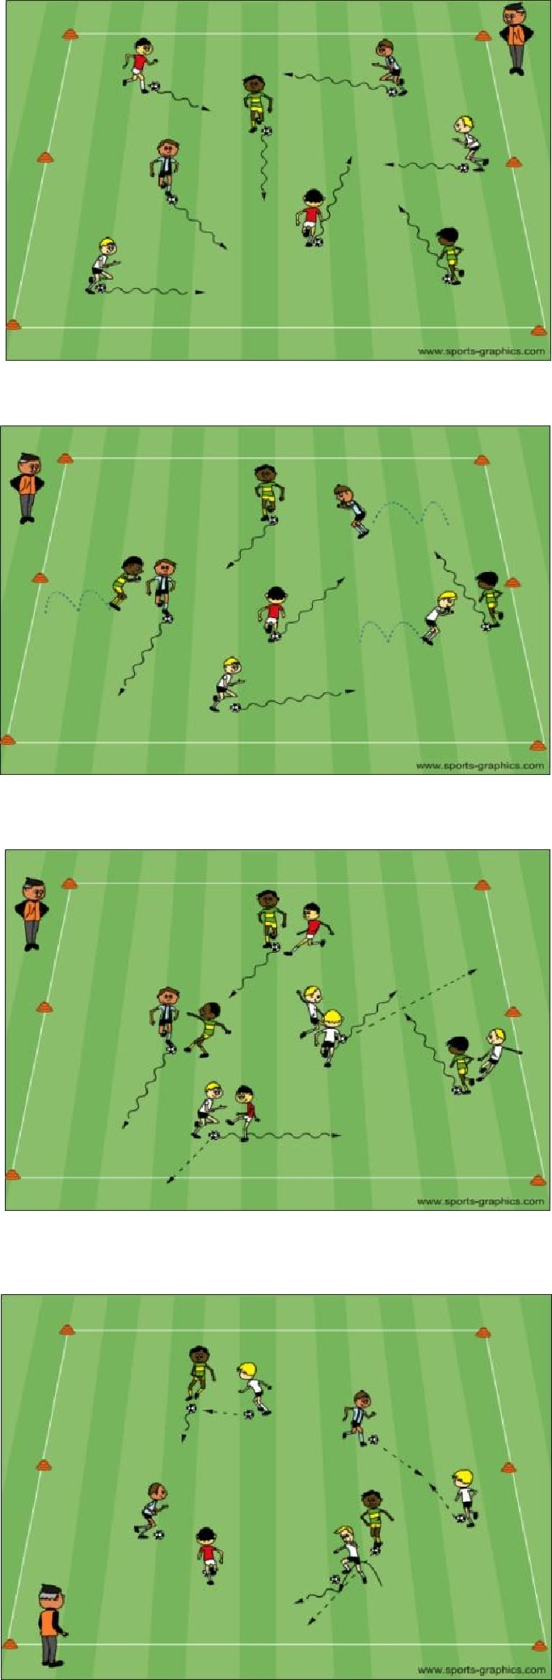

PDF to Word

