Topic: Shooting

Objective: To improve the technique of shooting with the
inside and instep of both feet

Technical Warm up |  |  |  | Organization |  |  |  | Coaching Pts.
 |  |  |  |  |  |  |  | • Body position and balance
 |  |  |  |  |  |  |  | • Eye on the ball at moment of
 | Shooting Though the Cones (15 min): |  |  |  |  |  |  | contact
 | Arrange players in 4 lines with a ball |  |  |  |  |  |  | • Strike ball with ankle locked
 | between them about 20-30 yards apart |  |  |  |  |  |  | and hard bone on top of foot
 | from | each |  | other. | Place | two | cones | • Non-kicking foot |  | directed at
 | representing a goal between each group |  |  |  |  |  |  | target
 | about | 6 | yards apart. Players shoot the |  |  |  |  | • Strike the center |  | of | the ball
 | ball and follow their shot to the opposite |  |  |  |  |  |  | and follow through |  |  | towards
 | side. |  |  |  |  |  |  | target | landing on |  | shooting
 |  |  |  |  |  |  |  | foot
 |  |  |  |  |  |  |  |  | Time: 15 minutes
Small Sided Game |  |  |  | Organization |  |  |  | Coaching Pts.
 | 4 Corner Shooting (15 min): |  |  |  |  |  |  | • Proper | technique | and |  | body
 | Two teams playing 2v2 with GK |  |  |  |  |  |  | control
 |  |  |  |  |  |  |  | • Placement vs. power
 | Coach |  |  |  |  |  |  | • Quality preparation touch
 | begins |  | the | play from the |  | sideline by |  | • Proper | selection | of | contact
 | serving a ball to player in any corner.
 |  |  |  |  |  |  |  | surface
 | Players try to score on their opponent’s
 |  |  |  |  |  |  |  | • Timing | and | shape |  | of
 | goal. Play continues until ball is out of
 |  |  |  |  |  |  |  | attacking runs
 | bounds |  | or | a goal | is scored. |  | Players
 |  |  |  |  |  |  |  | • Creativity and deception
 | return to their corners. (Rotate GK).
 |  |  |  |  |  |  |  | • Combination Play
 |  |  |  |  |  |  |  |  | Time: 15 minutes
Exp. Small Sided Game |  |  |  | Organization |  |  |  | Coaching Pts.
 | 2v2 Plus Team on Deck (15 min): |  |  |  |  |  |  | • Proper | technique | and |  | body
 | Two goals set up about 25-30
 |  |  |  |  |  |  |  | control
 | yards | apart. |  | Team | is divided |  | into 3
 |  |  |  |  |  |  |  | • Placement vs. power
 | groups. Two teams compete to score a
 |  |  |  |  |  |  |  | • Quality preparation touch
 | goal. The team that scores defends that
 |  |  |  |  |  |  |  | • Proper | selection | of | contact
 | goal. The team on deck comes onto the
 |  |  |  |  |  |  |  | surface
 | field to defend quickly while the scored
 |  |  |  |  |  |  |  | • Timing | and | shape |  | of
 | on team quickly leaves the playing field.
 |  |  |  |  |  |  |  | attacking runs
 | This game teaches teams to go to goal
 |  |  |  |  |  |  |  | • Creativity and deception
 | with pace and to take chances quickly.
 |  |  |  |  |  |  |  |  | Time: 20 minutes
Game |  |  |  | Organization |  |  |  | Coaching Pts.
3v3 or 4v4 | 3v3 in your area or 4v4 against the team |  |  |  |  |  |  | • All of the above
 | Next to you |  |  |  |  |  |  |  | Time: 30 minutes
COOL DOWN | Activities to reduce heart rate, static stretching & review session – Time 10 min.
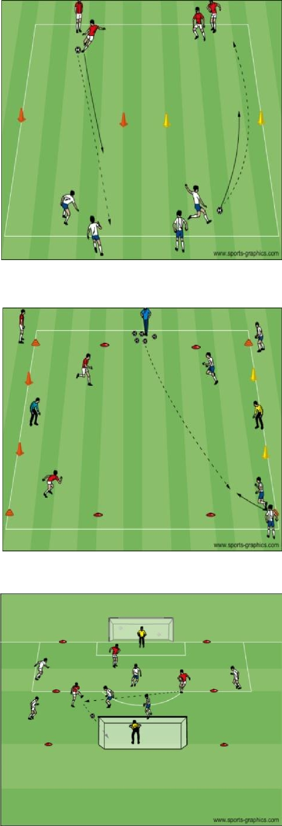

PDF to Word

